## SVN-Update

Step3:

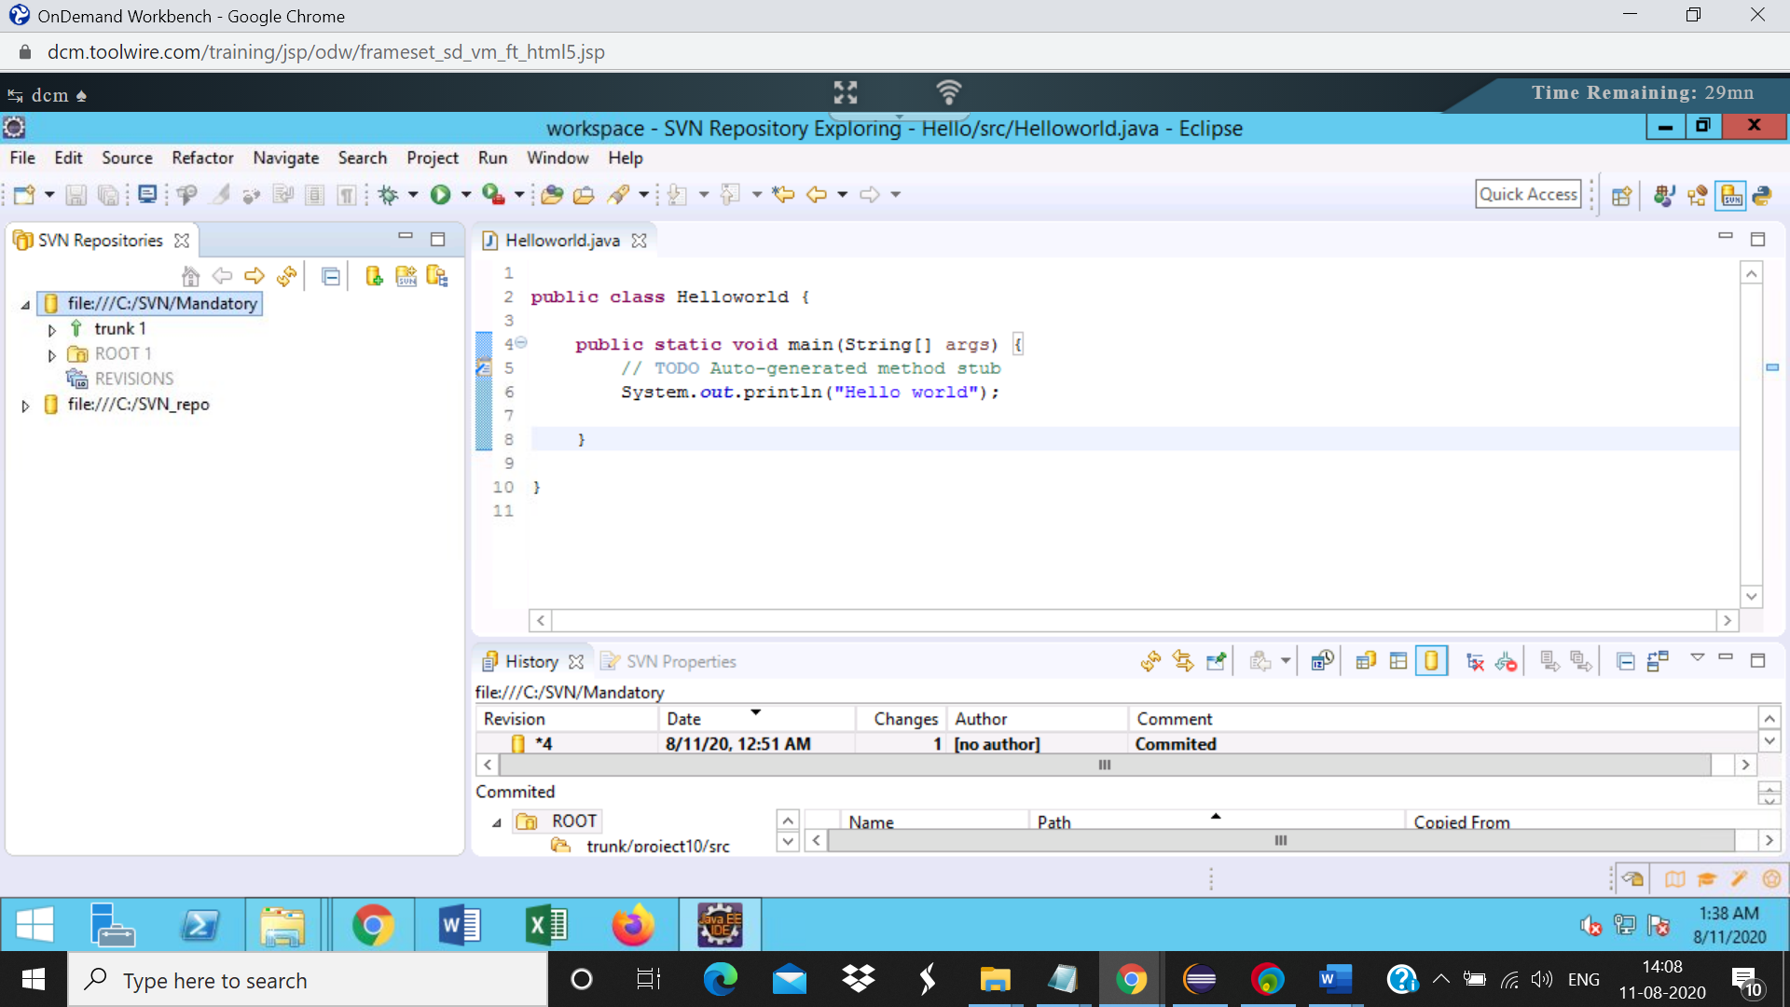

Step4: Right click on the project named as **project9** inside trunk and select Checkout

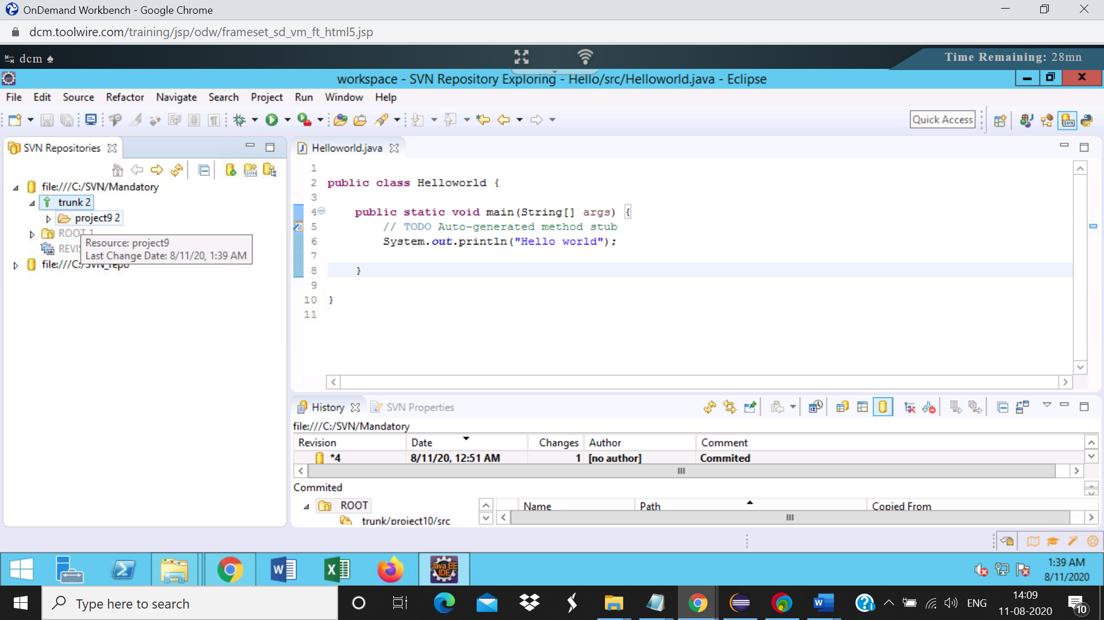

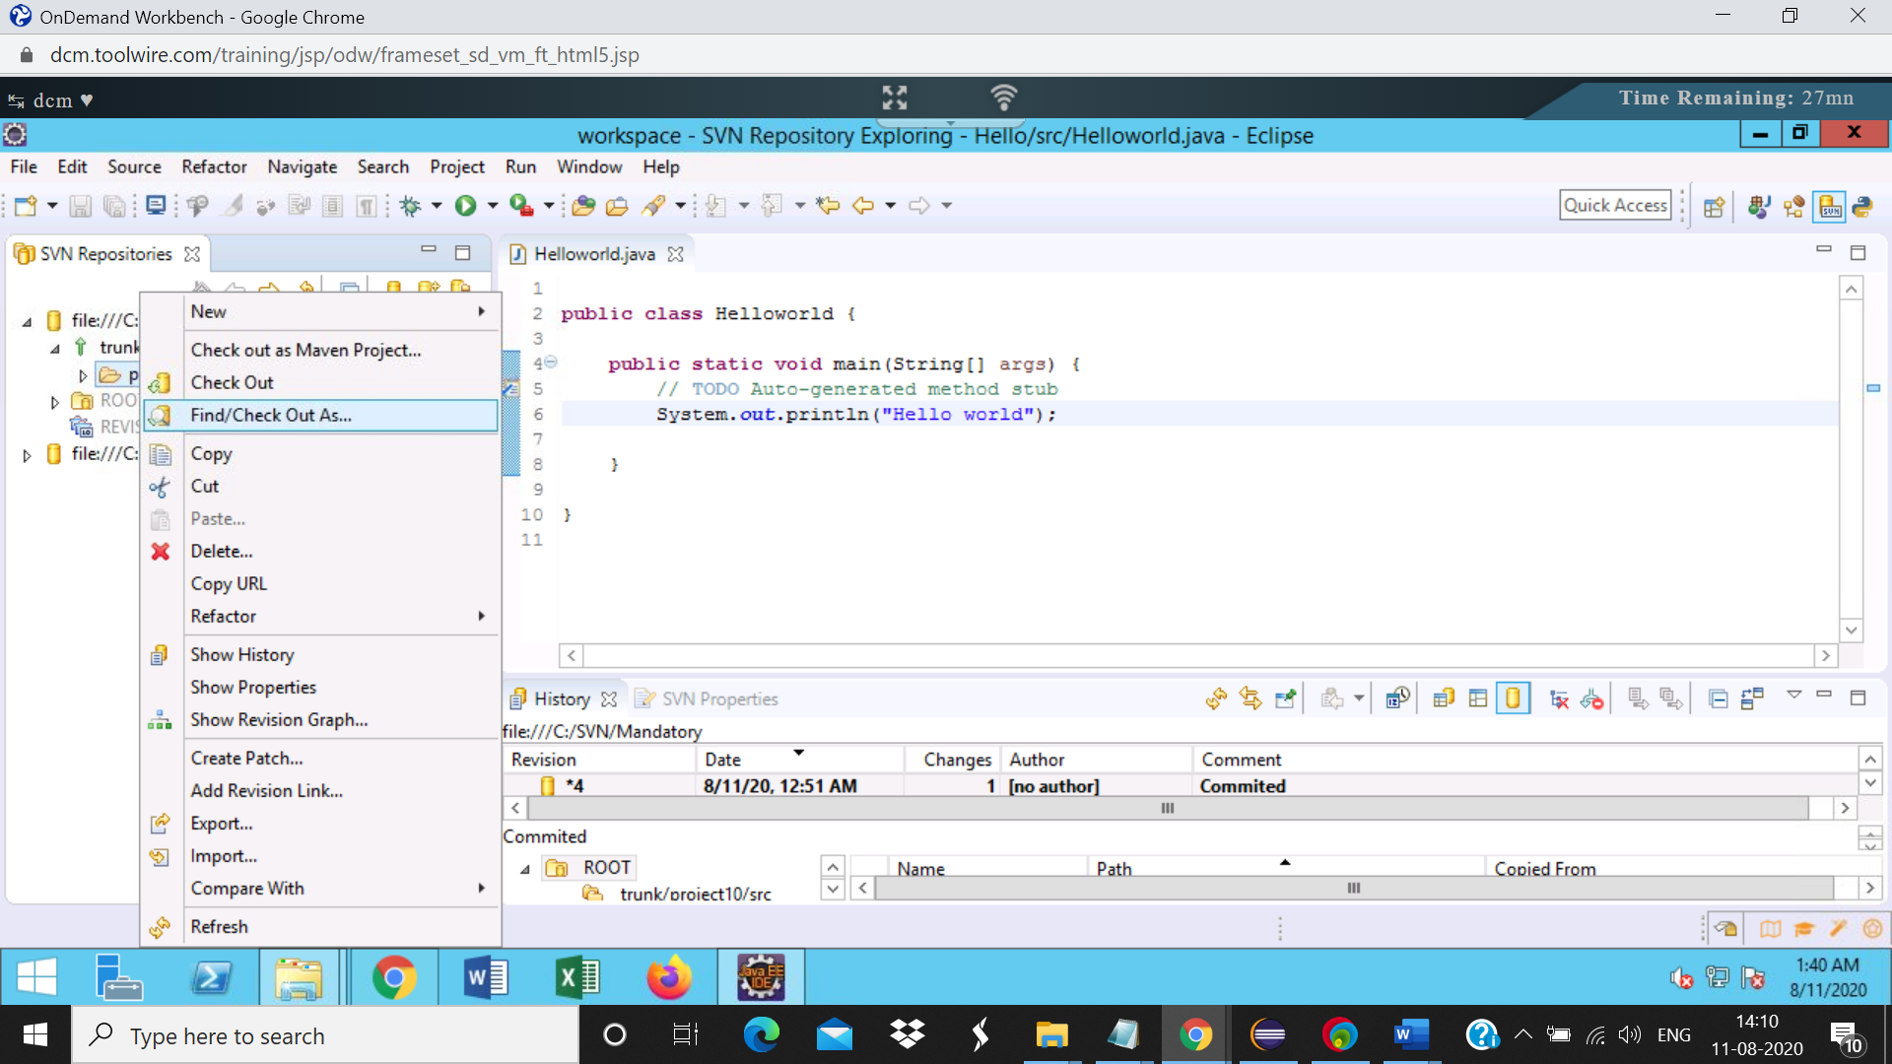

Step 5:

Select “Check out as a project in the workspace” and specify the project name in the Checkout from SVN dialog.  
Click on Finish  
The project will be checked out to the workspace.  
Project name: Shipment_user1

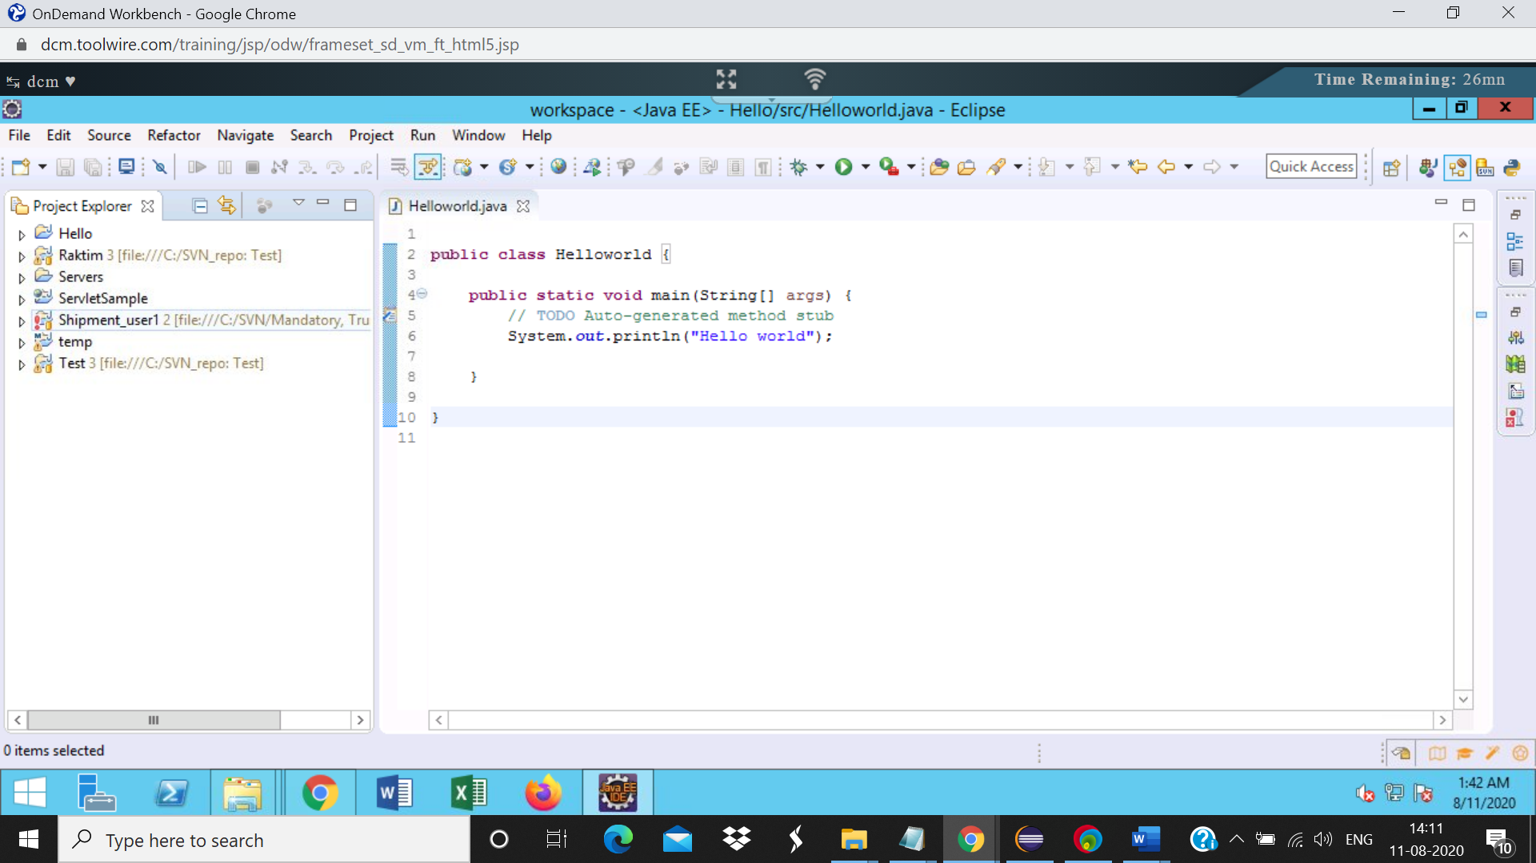

Step6: In the SVN Repository, check out the same project again with a different name.  
Project name: Shipment_user2

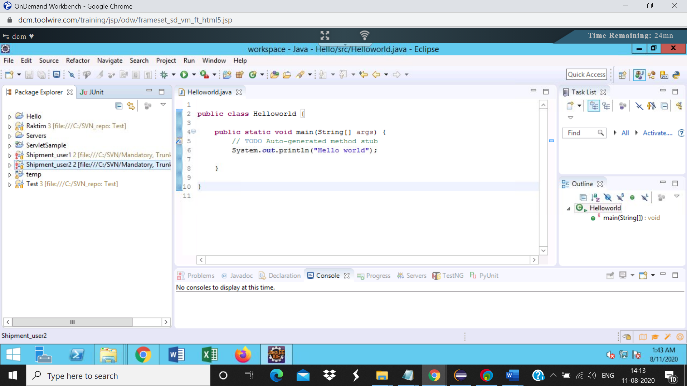Step8: Right click on the file, select Compare with->Latest from repository  
Verify that only the required changes are made.

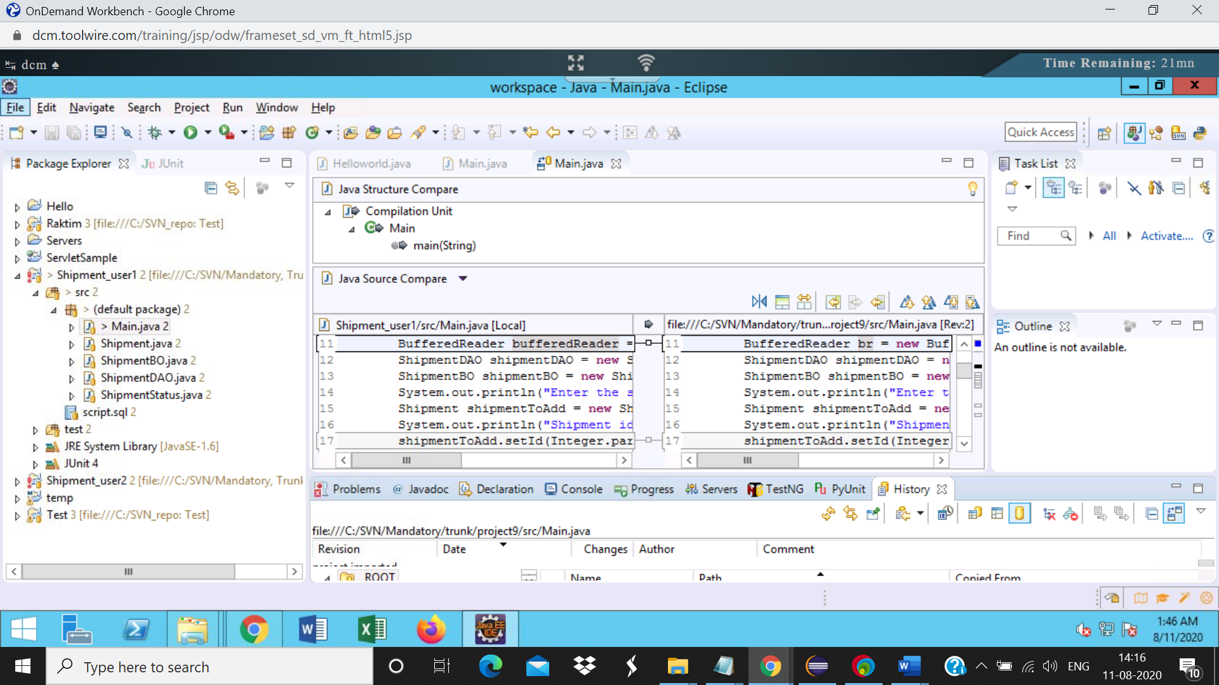Step 9:

Right click on the project, select team->commit  
Verify the files in the changes section of the commit dialog. Only the Main.java file should be present

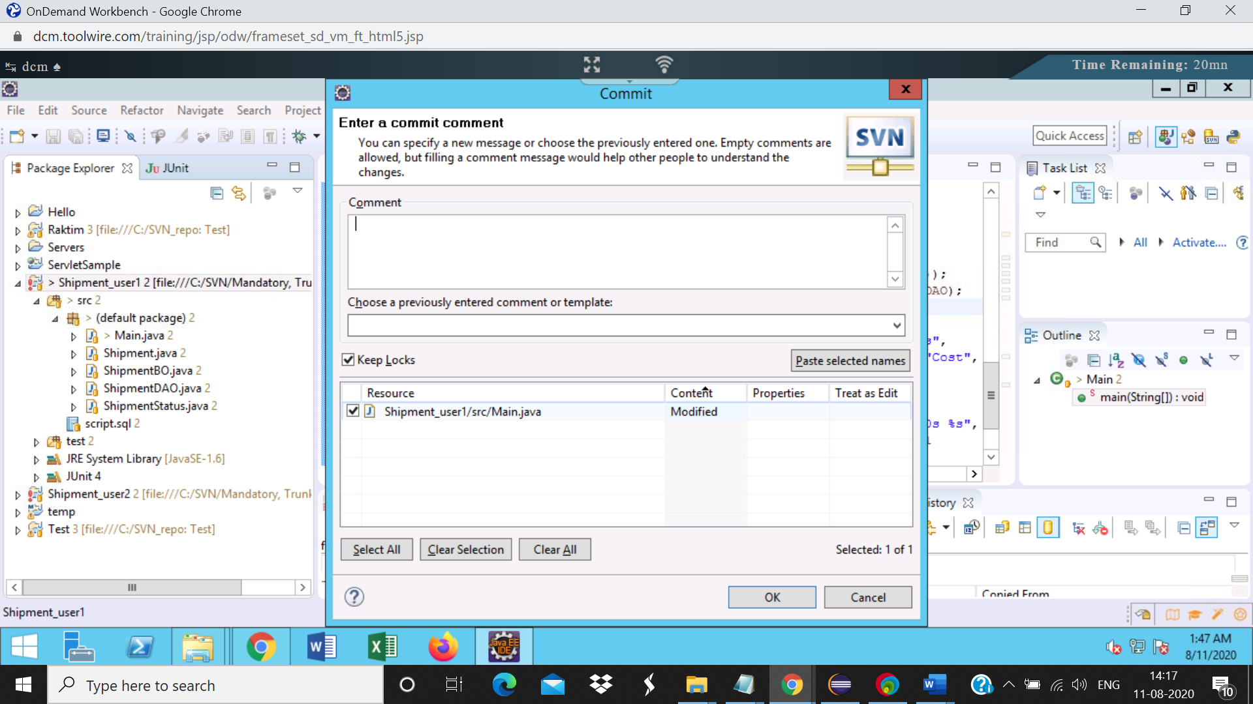

Step12: Right click on the project,  
select team->update to HEAD. No conflicts occurs, the project is updated successfully.  
Then select team->commit  
Verify the files in the changes section of the commit dialog. Only the ShipmentBO.java file should be present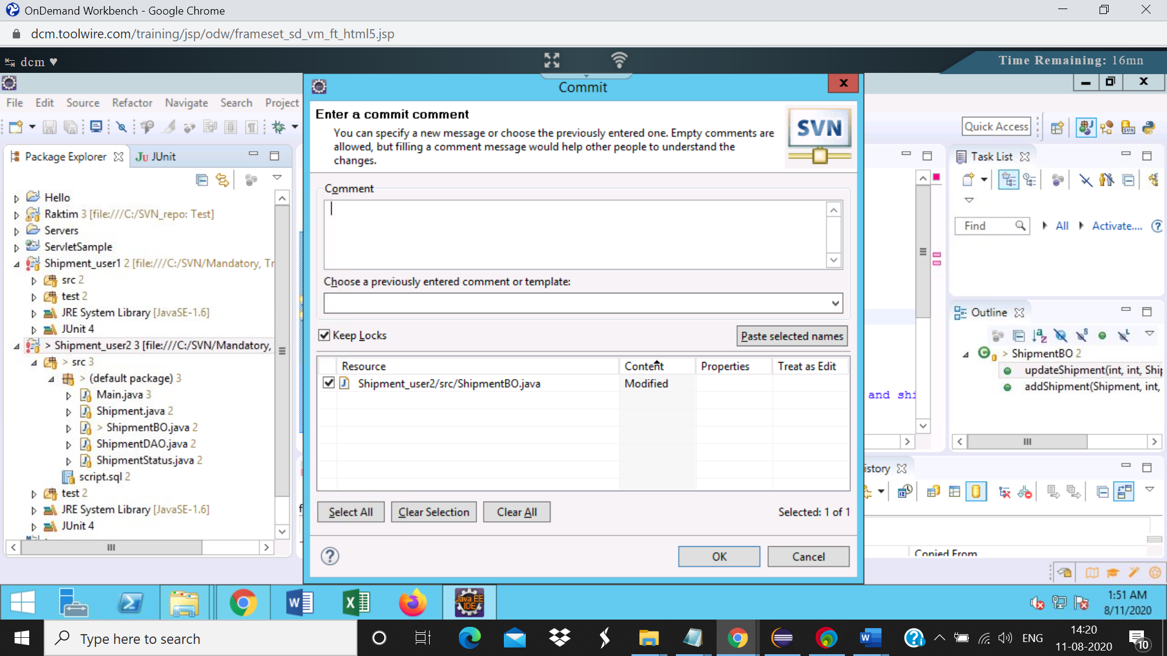

Step14:

Right click on the repository and select show history

